**AMAZON VIRTUAL ASSISTAN**

**JDC FREE IT CITY**

Muhammad Abdullah Sabir

AMZ-B02-6647

Batch 02

Sir Adnan Nazir

Monday (6pm to 8pm)

**Product Hunting**

My hunt is Luxurious, lightweight inflatable neck pillow offers maximum comfort in a compact package; ideal for airplane, car, and train travel.

**Black box;**



This particular product is highly appealing and lucrative to me as it generates a substantial monthly revenue of over $14,968. It has also received excellent reviews with a rating above 4.2, meeting the criteria set by UK standards. Moreover, the product boasts an impressive age of 49 months, indicating its long-standing success. Additionally, it offers a diverse range of three variations, further enhancing its appeal.

**CEREBRO;**



Based on the ASIN search results, I discovered a keyword related to "travel pillow" that has a search volume of over 145,546. Furthermore, the number of competing products for this keyword is less than>2000.

This indicates that there is relatively low competition in the market. To further analyze the potential, I examined the graph representing the search volume trend over time.

**CERERO GRAPH;**

The graph I reviewed displayed a one-year trend for the search volume of the keyword "travel pillow." The lowest recorded point on the graph was above 64,000, indicating a consistently high level of interest in the product over the past year.

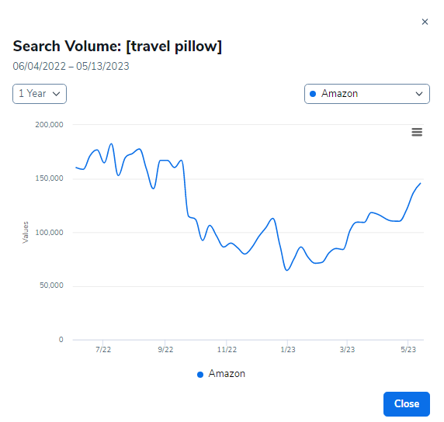

And

I analyzed represents the search volume trend for the keyword "travel pillow" over its entire history. The lowest recorded point on the graph indicates a minimum search volume of 26,000, suggesting consistent and sustained interest in the product over time.

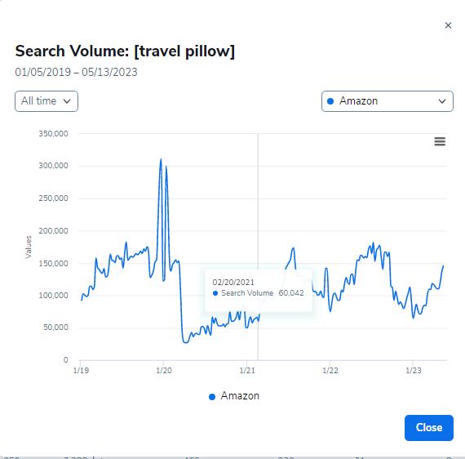.

**GOOGLE TREND;**

Based on the Google Trends graph, it can be observed that the keyword "travel pillow" does not exhibit a distinct trend or seasonality. The graph indicates that the interest in this product remains relatively consistent throughout different time periods, suggesting that it maintains a steady level of demand without being influenced by specific seasons or trends.

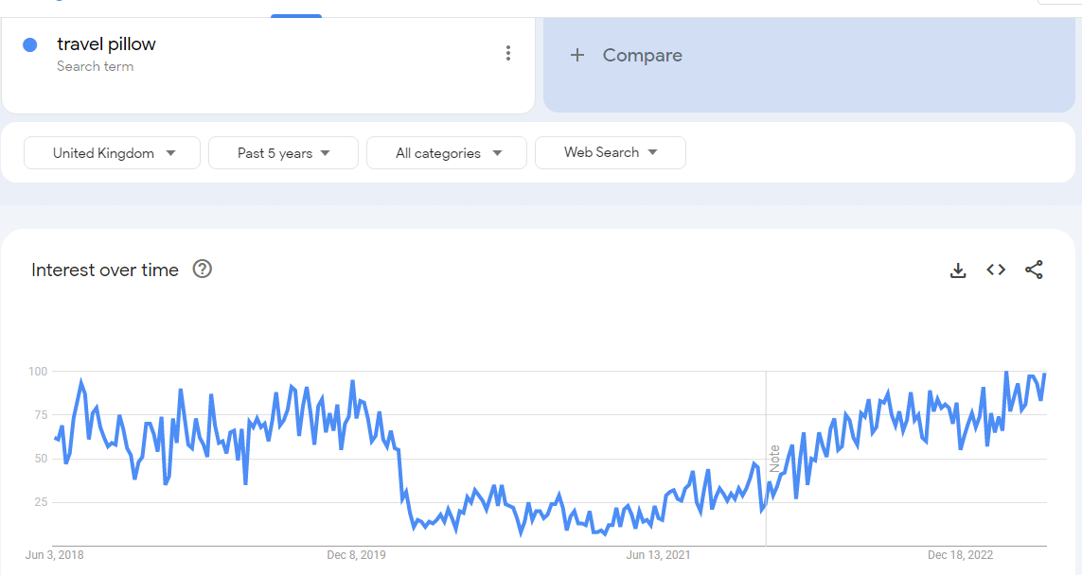

**Product Validation:**

**X-ray;**

After conducting an in-depth analysis of the top 25 products related to the keyword "travel pillow," several positive observations were made. Firstly, there is a presence of promising keywords associated with the product. Secondly, the pricing of these products appears to be consistent, which is an encouraging sign. Additionally, the level of competition in terms of reviews is relatively low, with most sellers having less than 500 reviews. This indicates a favorable opportunity to enter the market. Furthermore, it is worth noting that none of the sellers are affiliated with Amazon (AMZ), which suggests the potential for a gap in the market for a new seller to establish a presence.

**Unsorted Data;**

This graphical representation reveals the absence of brand monopolization, substantial search interest, and price uniformity**:**

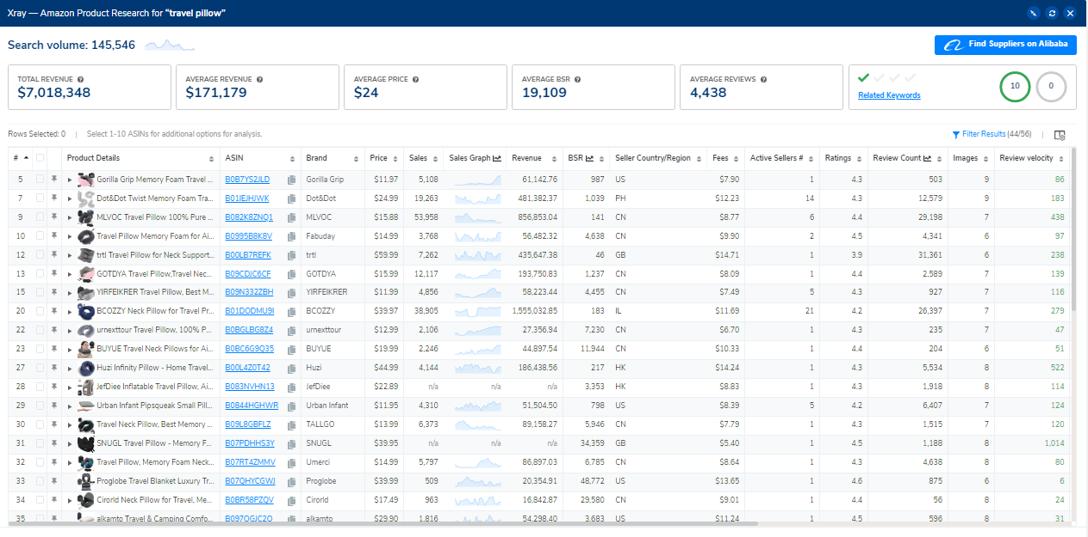

**And**

**This visual depiction illustrates the absence of Amazon (AMZ) presence, while also providing information on dimensions, weight, and listing age that align with our criteria:**

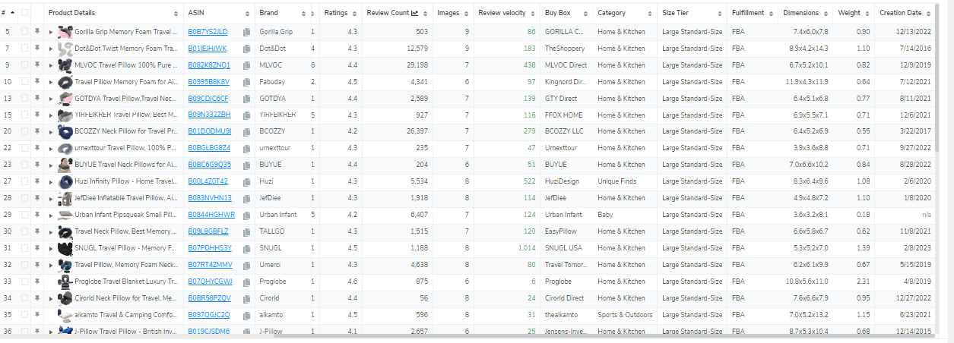

**Sorted Data:**

**Sorted by revenue;**

Upon sorting the data by revenue from highest to lowest, it becomes evident that there is no significant impact on price consistency. Additionally, the analysis reveals that there is a diverse pool of sellers, indicating that no single seller monopolizes all the products. Furthermore, there is no discernible change in the review rating.

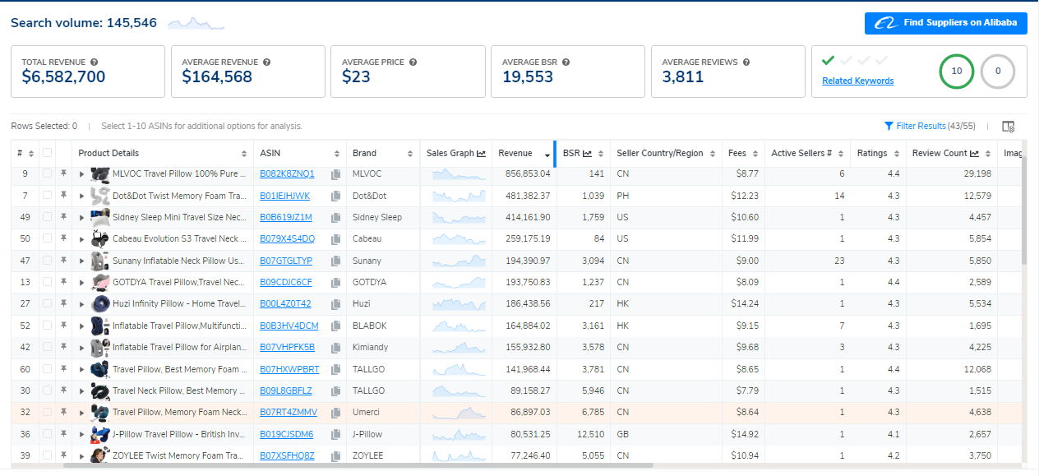

**Sorted by review;**

After arranging the data by review rating, a clear observation emerges, indicating that sellers with lower review ratings are still able to generate substantial revenue, as depicted in the figure**.**

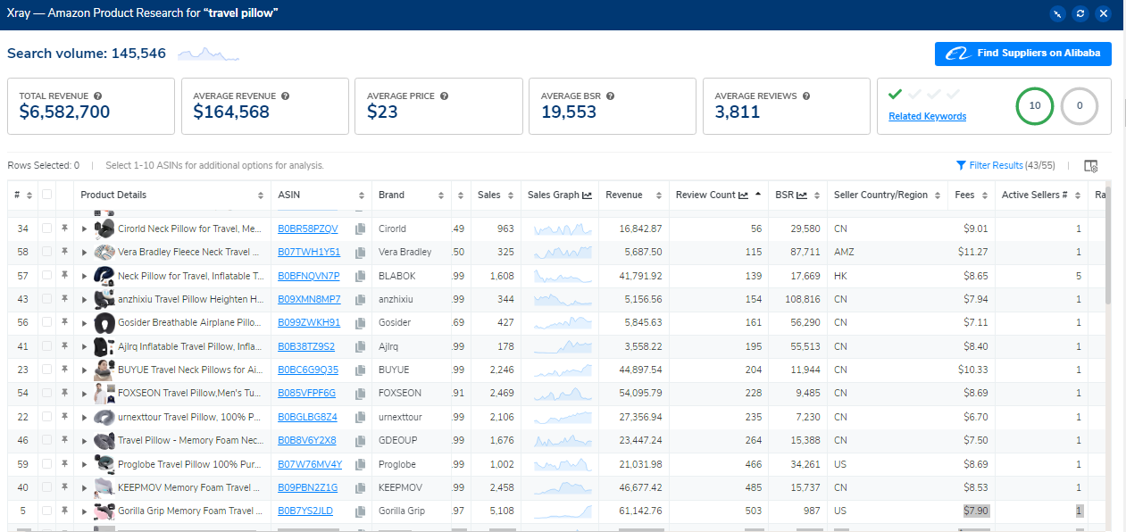

**Sorted by data;**

Upon sorting the data by creation date, a notable pattern emerges, revealing a significant presence of newly established sellers with lower review ratings who are nevertheless experiencing substantial earnings, as evidenced below:

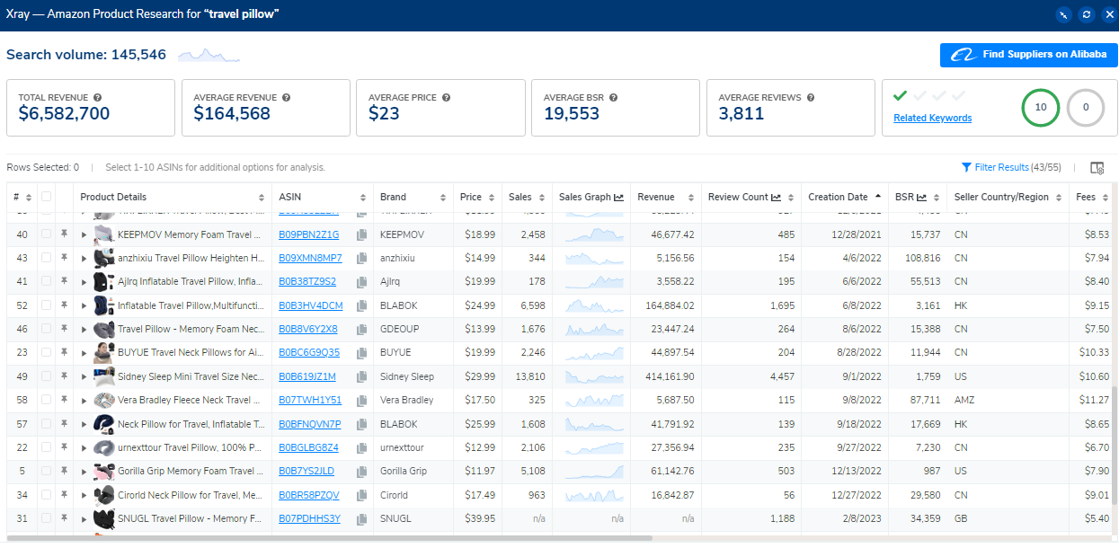

.

Conclusion:

the dataset suggests a competitive marketplace with a range of sellers, where new and less-established sellers can achieve success despite lower review ratings. Price consistency and search volume remain stable, while the absence of a dominant brand and Amazon as a seller further diversify the market.